# Projects around the ATMEGA 1284P and 328P

**This is a working draft 13/11/2020.**

**De Docx niet meer gebruiken verder gaan in Expression Web****<--Back**

Contents

Project around the ATMEGA 1284P and 328P 1

Project around the ATMEGA 1284P 3

The ATMEGA 328P and 1284P processor 4

Needs for the project 6

Install the libraries in the Arduino IDE 7

The PCB 8

Burning a bootloader on the 1284P 8

Use a FTDI to program the chip 11

Turning on and off LED’s 13

Measuring the Crystal frequency 14

Turn a 5V PWM signal to a 12V PWM signal 15

Lower a 5V signal to a 3.3 V signal 15

Lower 7V – 15V to 5 V 16

Use the DCF77 time receiver 17

Using a FM-radio to receive time from the RDS signal and tune to a station 23

Using a GPS to receive time and position on the globe 29

Use the Bluetooth HC-05 and HM-10 4.0 BT-BLE modules to send and receive messages 29

Change the name of a HM10 BLE with an FTDI 34

Communicate with Android, Windows and Apple devices 35

Communicate with a LCD display 35

Communicate with a 128 by 64 pixel 12864 OLED display 37

Display on a 8 Digit LED Display MAX7219 7 Segment Digital Tube 37

Add a temperature sensor Dallas DS1820 39

The WS2812 colour LEDS 42

Use buttons 42

Use a rotary 43

Adjust some 1284P features 43

Some knowhow of the 1284P 43

# Projects around the ATMEGA 328 and 1284P

For people born in the 50-ties of the previous century the Arduino brings back hobbies from their youth.   
When I was around 20 the first calculators became affordable. Later the Commodore 64, Acorn BBC B computer and then MS-DOS on IBM-compatible PC were the standard. I learned programming in Lattice C and couple device to the PC. For the single programmer like me C-programming ended when C++ compilers were designed to work with projects. Borland C V4 was for me the last and almost perfect IDE. After W95 and the connection to internet computers became more secure. Now with Windows 10 and IPad’s, the systems were consumable and closed devices. You need assistance from external companies to connect their closed devices to your computer system and dozens of people to open network ports, allow access to the completed closed PC.

The Arduino and Raspberry computers are therefore not surprisingly extremely interesting for people just in or on the brink of their retirement and a lot of time to spent and learn again.

I chose the Arduino and used the Word clock as a project to start to learn simple electronics and use my programming skills to hobby again.

The Arduino offers a simple IDE (integrated development environment) and C as programming language. Raspberry’s are using that difficult to operate UNIX and is far too powerful for the smaller projects.

The ATMEGA1284P processor from ATMEL has more program memory than the ATMEGA328; 128K instead of 32K memory. Especially when several libraries are used in the project, WS2812 RGB and SK6812 RGBW LEDs are added, 32K of memory becomes tight. For these purposes Arduino developed the Arduino Mega around the ATMEGA2560 chip. But for the amateur electronic this is troublesome because this is a SMD chip and difficult to solder. The ATMEGA1284P is a large 40 pin chip that can be easily incorporated in a self-made PCB. This project is an enhancement of the ATMEGA328 version of the Word clock PCB.

During the evolution of software and hardware around a Word clock several input and output possibilities were required. That is a clock module, bit shift registers to control LEDS or relays at a higher voltage level than 5V, Bluetooth connection, DCF77, FM-radio and GPS receivers to adjust the time to atomic time clock transmitters. Burning the chip on the PCB with a FTDI connection to a PC, working at voltage levels of 3.3V, 5V and 12V and pulse width modulation to adjust the LED intensity. Also working with RGB WS2812 LED’s was one of the needs.

I realised that the designed board became a universal board with large and easy to solder DIP ATMEGA 328 or ATMEGA 1284P processor as the base.

Several source codes are located [here](Source_INO_files) and [here on Github](https://github.com/ednieuw)

By using #define’s attached modules and their coding can be turned on or off. The program is tested and can be used with ATMEGA328 chip, an Arduino UNO, Arduino Nano or an ATMEGA1284P. Programming with the 1284P has some quirks that had to be written down and here is the article ‘How to Do’ this.

## The ATMEGA 328P and 1284P processor

ATMEL produces many processors with many possibilities. The ATMEGA 328P processor is used in the Arduino Uno and very popular. 328 stand for 32 KB memory 8 bits addressing. The 1284P has 128K memory and also 8 bits addressing. The P stands for PicoPower. In this article we use the P versions of the chip. The –PU stands for PDIP package that are the dual-line 28 (328) or 40 pin (1284) chips.

So, when looking for the processors; buy the 328P-PU or 1284P-PU chips.

Beside the memory size of the chip there are also differences in the amount of pins on the chip, 28 versus 40 and therefore also the number of analogue and digital ports.

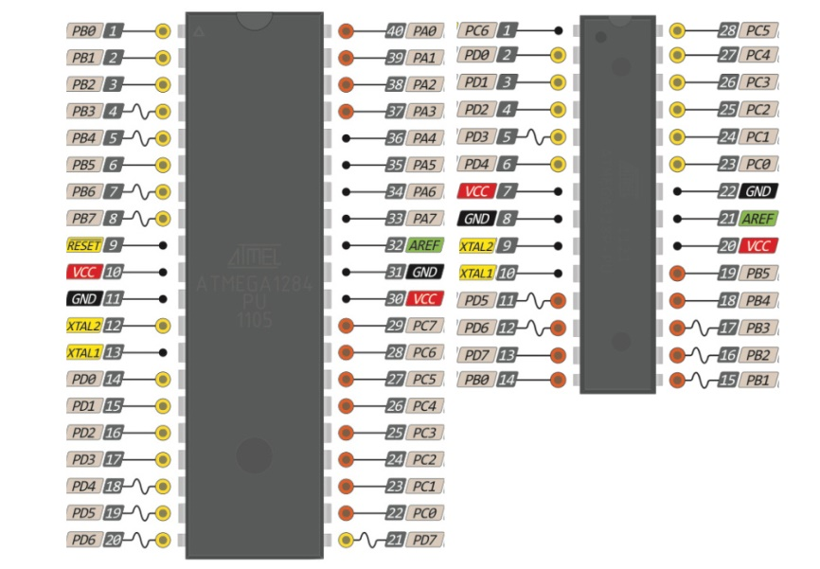

The other characteristics of the processors are comparable. Both processors operate at voltages between 1.8V and 5.5V. The low voltage of 1.8V can be used when oscillators between 0 and 4 MHz are used. The chip contains an internal oscillator that runs at 8 MHz. We will use an external oscillator of 16 MHz. This should be used after burning the bootloader in the chip. The bootloader supplied with the Arduino IDE’s for this chip runs at 16 MHz and needs a working voltage between 4.5V and 5.5V to run at this speed. One can use these chips for low power consumption projects because the chip also has many sleep modes possibilities.

Features of the ATMEGA processors noted on their datasheets

|  |  |
| --- | --- |
| **1284P** | **328P** |
| • High-performance, Low-power AVR® 8-bit Microcontroller  • Advanced RISC Architecture  – 131 Powerful Instructions – Most Single-clock Cycle Execution  – 32 x 8 General Purpose Working Registers  – Fully Static Operation  – Up to 20 MIPS Throughput at 20 MHz  – On-chip 2-cycle Multiplier  • Nonvolatile Program and Data Memories  – 128K Bytes of In-System Self-Programmable Flash  Endurance: 10,000 Write/Erase Cycles  – Optional Boot Code Section with Independent Lock Bits  In-System Programming by On-chip Boot Program  True Read-While-Write Operation  – 4K Bytes EEPROM  Endurance: 100,000 Write/Erase Cycles  – 16K Bytes Internal SRAM  – Programming Lock for Software Security  • JTAG (IEEE std. 1149.1 Compliant) Interface  – Boundary-scan Capabilities According to the JTAG Standard  – Extensive On-chip Debug Support  – Programming of Flash, EEPROM, Fuses, and Lock Bits through the JTAG Interface  • Peripheral Features  – Two 8-bit Timer/Counters with Separate Prescalers and Compare Modes  – Two 16-bit Timer/Counter with Separate Prescaler, Compare Mode, and Capture  Mode  – Real Time Counter with Separate Oscillator  – Six PWM Channels  – 8-channel, 10-bit ADC  Differential mode with selectable gain at 1x, 10x or 200x  – Byte-oriented Two-wire Serial Interface  – Two Programmable Serial USART  – Master/Slave SPI Serial Interface  – Programmable Watchdog Timer with Separate On-chip Oscillator  – On-chip Analog Comparator  – Interrupt and Wake-up on Pin Change  • Special Microcontroller Features  – Power-on Reset and Programmable Brown-out Detection  – Internal Calibrated RC Oscillator  – External and Internal Interrupt Sources  – Six Sleep Modes: Idle, ADC Noise Reduction, Power-save, Power-down, Standby  and Extended Standby  • I/O and Packages  – 32 Programmable I/O Lines  – 40-pin PDIP, 44-lead TQFP, and 44-pad QFN/MLF  • Operating Voltages  – 1.8 - 5.5V for ATmega1284P  • Speed Grades  – 0 - 4 MHz @ 1.8 - 5.5V  – 0 - 10 MHz @ 2.7 - 5.5V  – 0 - 20 MHz @ 4.5 - 5.5V  • Power Consumption at 1 MHz, 1.8V, 25°C  – Active: 0.4 mA  – Power-down Mode: 0.1 μA  – Power-save Mode: 0.7 μA (Including 32 kHz RTC) | • High-performance, Low-power AVR® 8-bit Microcontroller  • Advanced RISC Architecture  ̶ 131 Powerful Instructions – Most Single Clock Cycle Execution  ̶ 32 x 8 General Purpose Working Registers  ̶ Fully Static Operation  ̶ Up to 20 MIPS Throughput at 20MHz  ̶ On-chip 2-cycle Multiplier  •High Endurance Non-volatile Memory Segments  ̶ 32KBytes of In-System Self-Programmable Flash program memory  ̶ 1KBytes EEPROM  ̶ 2KBytes Internal SRAM  Write/Erase Cycles: 10,000 Flash/100,000 EEPROM  ̶- Data retention: 20 years at 85C/100 years at 25C(1)  ̶ Optional Boot Code Section with Independent Lock Bits  ̶ In-System Programming by On-chip Boot Program  ̶True Read-While-Write Operation  ̶ Programming Lock for Software Security  -Atmel® QTouch® library support  ̶ Capacitive touch buttons, sliders and wheels  ̶ QTouch and QMatrix® acquisition  ̶ Up to 64 sense channels  • Peripheral Features  ̶ Two 8-bit Timer/Counters with Separate Prescaler and Compare Mode  ̶ One 16-bit Timer/Counter with Separate Prescaler, Compare Mode, and  Capture Mode  ̶ Real Time Counter with Separate Oscillator  ̶ Six PWM Channels  ̶ 8-channel 10-bit ADC in TQFP and QFN/MLF package  - Temperature Measurement  ̶ 6-channel 10-bit ADC in PDIP Package  ̶ Temperature Measurement  ̶ Programmable Serial USART  ̶ Master/Slave SPI Serial Interface  ̶ Byte-oriented 2-wire Serial Interface (Philips I2C compatible)  ̶ Programmable Watchdog Timer with Separate On-chip Oscillator  ̶ On-chip Analog Comparator  ̶ Interrupt and Wake-up on Pin Change  ̶ Power-on Reset and Programmable Brown-out Detection  ̶ Internal Calibrated Oscillator  ̶ External and Internal Interrupt Sources  ̶ Six Sleep Modes: Idle, ADC Noise Reduction, Power-save, Power-down, Standby, and Extended Standby  • I/O and Packages  ̶ 23 Programmable I/O Lines  ̶ 28-pin PDIP, 32-lead TQFP, 28-pad QFN/MLF and 32-pad QFN/MLF  • Operating Voltage:  ̶ 1.8 - 5.5V  Temperature Range:̶ -40C to 85C  • Speed Grade:  ̶ 0 - 4MHz@1.8 - 5.5V,  0 - 10MHz@2.7 - 5.5.V,  0 - 20MHz @ 4.5 - 5.5V  • Power Consumption at 1MHz, 1.8V, 25C  ̶ Active Mode: 0.2mA  ̶ Power-down Mode: 0.1μA  ̶ Power-save Mode: 0.75μA (Including 32kHz RTC) |

## Needs for the project

|  |  |
| --- | --- |
| As written before the project is built around a word clock. This clock drives 23 LEDs strips to make up the words that light up in matrix of letters to tell the time. Like: It was “five past three”  Here the text displays the words in Dutch:  “Het was half zes”. That translates to:  It was half past five.  This clock uses Shift registers combined with a Darlington transistor array ICs to switch from 5V to 12V to turn on or off LED strips voltage, |  |
| Bluetooth connection to set time and turn on- off features, a DS3231 clock module with I2C connection, FTDI connection to program the chip, rotary or button control, RDS time receiver from an RDA5807 FM-radio module and a LCD or OLED display connection, a 8 digit LED display and a Dallas temperature sensor.  To make the word clock with RGB colour LEDs instead of white LED strips, WS2812 RGB LED’s were used.  All together a project that uses many techniques and a lot of research.  The project is built around the standard ATMEGA 328 chip with 32K memory or the 1284 processor chip with 128K memory. | |

The programming environment from Arduino: Download

IDE 1.8.13 of higher from: <https://www.arduino.cc/en/Main/Software>

Libraries: Download or install

------------------------------------------------------

<https://github.com/mcudude/MightyCore> Library for the 1284P board

**Boards Manager Installation**

This installation method requires Arduino IDE version 1.6.4 or greater.

•Open the Arduino IDE.

•Open the File > Preferences menu item.

•Enter the following URL in Additional Boards Manager URLs: https://mcudude.github.io/MightyCore/package_MCUdude_MightyCore_index.json   
◦Separate the URLs using a comma ( , ) if you have more than one URL

•Open the Tools > Board > Boards Manager... menu item.

•Wait for the platform indexes to finish downloading.

•Scroll down until you see the MightyCore entry and click on it.

•Click Install.

•After installation is complete close the Boards Manager window.

------------------------------------------------------

<https://github.com/fdebrabander/Arduino-LiquidCrystal-I2C-library> LiquidCrystal_I2C

All other used libraries are Arduino standard libraries.

## Install the libraries in the Arduino IDE

If everything is installed from the Arduino IDE (Open from the IDE menu: Sketch🡪 Include library 🡪

Manage libraries) you will see the following directories in your library folder. The library folder is stored between you script folders in the Arduino folder in your Documents folder:

<DIR> Encoder

<DIR> LedControl

<DIR> MAX31850_DallasTemp

<DIR> NewliquidCrystal

<DIR> OneWire

<DIR> RTClib

<DIR> Time

<DIR> TM1638

The includes:

#include <Wire.h>

#include <LiquidCrystal_I2C.h>

#include <RTClib.h>

#include <EEPROM.h>

#include <SoftwareSerial.h>

#include <Encoder.h>

#include "DCF77.h"

#include "TimeLib.h"

#include <LedControl.h>

#include <DallasTemperature.h>

## The PCB

The 1284P PCB (printed circuit board) is not essential. (Send me a [mail](../../email.html) if you want a spare one)  
You can wire and solder the project up yourself. The project will be split in project parts and every part can work on itself with the ATMEGA1284P or 328P processor chip.

I use Fritzing to design my PCB. Download the Fritzing design program here: <http://fritzing.org/download/>

The Fritzing file of this PCB can be found here:

<https://ednieuw.home.xs4all.nl/Woordklok/ATMEGA1280P_Project/Woordklok1284PV10.zip>

|  |  |
| --- | --- |
|  |  |

## Burning a bootloader on the 1284P

When processor chips are bought they are often without bootloader and then this must be installed on it.

The bootloader is a small program and during burning the bootloader also different settings (fuses) are set for the chip. Something like the bios in PC’s but then as a program. After power up or a reset of the processor the bootloader starts and listen to the RX and TX pins for a short time. In that time a program can be uploaded in the processor and started. It is possible to burn a program directly in the chip without a bootloader to spare approximately 1K of memory. For me that is too much fuss. As can be seen later using the bootloader makes life easier and the chip easy to reprogram.

For fuses and lock bits see: <http://www.engbedded.com/fusecalc>

There are 8 bits in the low fuse byte. These 8 bits are explained here:

•Bit-7: CKDIV8: When set divides the clock speed by 8

•Bit-6: CKOUT: When set clock pulses are output on PB0 (Pin 14)

•Bit-5: SUT1: Startup time delay

•Bit-4: SUT0: Startup time delay

•Bit-3: CKSEL3: Set the clock source

•Bit-2: CKSEL2: Set the clock source

•Bit-1: CKSEL1: Set the clock source

•Bit-0: CKSEL0: Set the clock source

There are 8 bits in the high byte fuse also. These are:

•Bit-7: RSTDISBL: External Reset disable

•Bit-6: DWEN: Debug Wire enable

•Bit-5: SPIEN: Enable serial programming and data downloading

•Bit-4: WDTON: Watchdog timer always on

•Bit-3: EESAVE: Preserve EEPROM memory through chip erase

•Bit-2: BOOTSZ1: Sets the bootloader memory size

•Bit-1: BOOTSZ0: Sets the bootloader momory size

•Bit-0: BOOTRST: Select the reset vector

Download: <https://github.com/mcudude/MightyCore>

This installation method requires Arduino IDE version 1.8 or higher.

Open the Arduino IDE.

Open the **File > Preferences** menu item.

Enter the following URL in **Additional Boards Manager URLs**: https://mcudude.github.io/MightyCore/package_MCUdude_MightyCore_index.json

Open the **Tools > Board > Boards Manager...** menu item.

Wait for the platform indexes to finish downloading.

Scroll down until you see the **MightyCore** entry and click on it.

**Note**: If you are using Arduino IDE 1.6.6 then you may need to close **Boards Manager** and then reopen it before the **MightyCore** entry will appear.

Click **Install**.

After installation is complete close the **Boards Manager** window.

Open in Tools of the IDE 🡪 Board 🡪 board manager

Install MightyCore by MCUdude

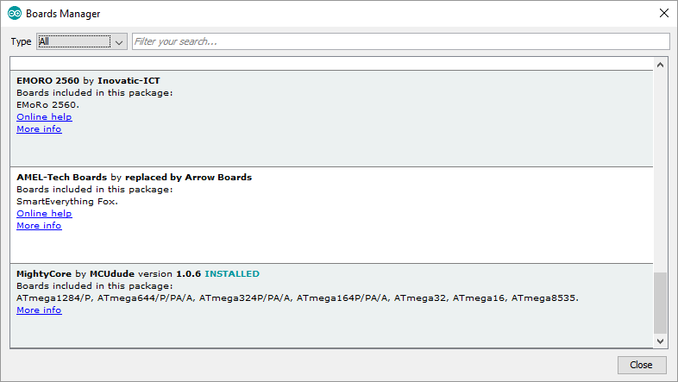

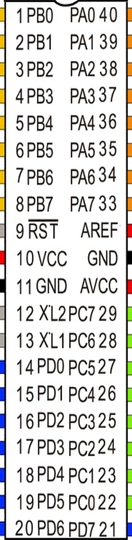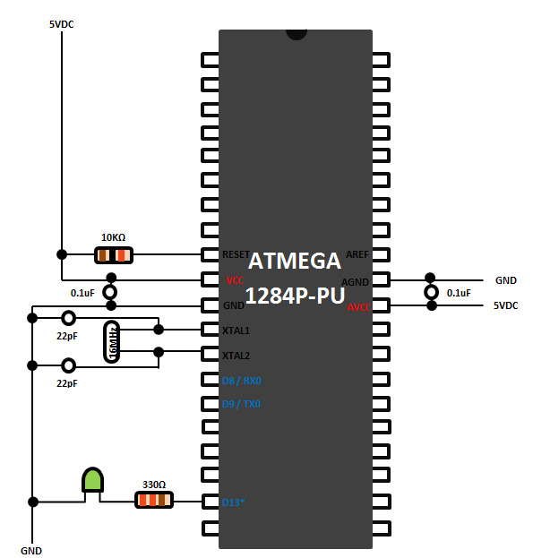

Parts:

Resistors 10kΩ, 330Ω 1/4W

Crystal 16 MHz

Two ceramics 22 pF capacitors

Two 0.1 µF electrolytic capacitors

Connect the part as shown above.

Connect a LED between a 330 ohm resistor and pin PD5 (D13) of the 1284P processor and connect the other pin to ground. This will blink the LED13 in the Blink program

Connect a LED between a 330 ohm resistor and pin 9 of the Arduino for the ‘heartbeat’ and connect the other pin to ground.

Connect Arduino pin 10 to Reset.

Connect Arduino pin 11 to PB5.

Connect Arduino pin 12 to PB6.

Connect Arduino pin 13 to PB7.

Connect VCC and GND of the Arduino to the power supply on the breadboard.

1. Load the program ArduinoISP from the examples in the IDE in an Arduino Uno with board settings: Aduino UNO.
2. Change board setting in the IDE to ATMEGA 1284 and
3. Choose 1284p as variant and B.O.D. = 2.7V, Pinout: standard, Clock: 16 MHZ external
4. Programmer: “Arduino as ISP”
5. Burn the bootloader to the ATMEGA1284p (in menu Tools -> burn bootloader).
6. Write a ‘B’ on the chip so you know the chip had a bootloader in it.

## Use a FTDI to program the chip

|  |  |
| --- | --- |
| To upload a program in to the ATMEGA a FTDI FT232RL USB to serial breakout board is used. This piece of hardware takes care of the communication between the USB port of the PC and the serial port on the ATMEGA chip. Before a program can start to upload the bootloader in the processor chip is activated by pulling down the Reset on the chip for a short period. This is done by the DTR-signal from the FTDI board. A 0.1 µF capacitor between DTR and RST makes a nice signal drop on the reset pin.  Pull the reset wire from the Arduino UNO pin 10 and connect the other 0.1uF capacitor pin of the FTDI DTR.  DTR <-> 0.1uF <-> Pin 9 RST ATMEGA1284P  Remove the VCC and GND wires from the Arduino. | CP2102 MICRO USB to UART TTL Module |
| Place the FTDI in the breadboard with the ATMEGA1284P  Connect the DTR to the 0.1uF capacitor. Connect other pin of the the 0.1uF capacitor to Reset pin9 of the ATMEGA1284P. Connect a 10k resistor between Reset pin9 and 5V  Connect from the FTDI module: Rx to PD1, Tx to PD0, VCC to VCC, Do not connect CTS and GND to GND.  Now you can upload a program from the IDE to the ATMEGA1284P. | |

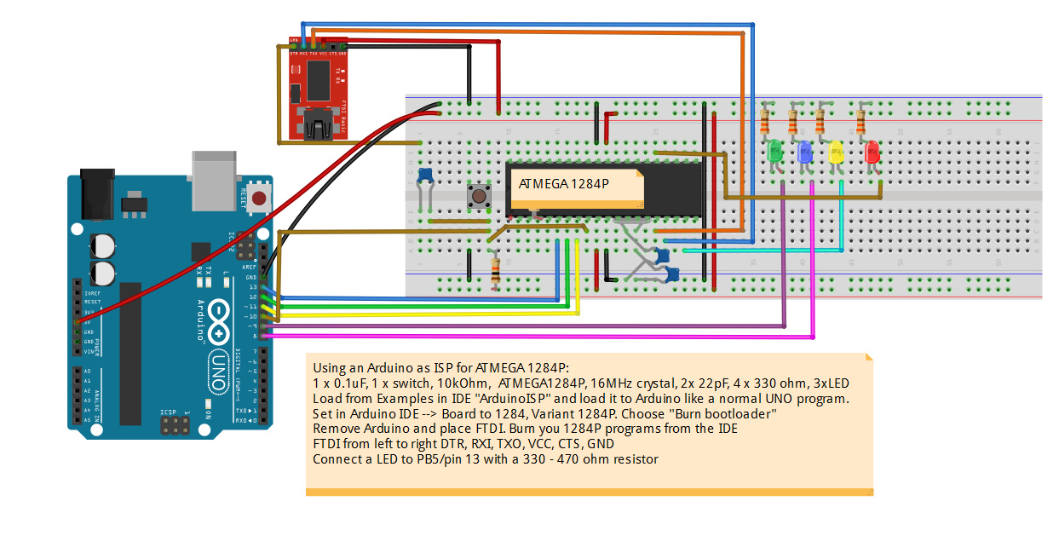

## Turning on and off LED’s

On the board several pins are connected to a LED. It is, of course possible to use these connections for other controls and leave the resistor and LED out the board. Pins 7, 14 and 15 can be used for a PWM-signal. Pins 5, 10 and 19 are digital pins. In the program below all pins are written to as analogue pins with values between 0 and 255. Pin 15 was not flagged as a PWM pin in the schematic shown above but it behaves as a PWM pin because the LED faints like a heartbeat like pin 7 and 14.

|  |  |
| --- | --- |
| [ATMEGA1284-heartbeat5_PWM.ino](https://ednieuw.home.xs4all.nl/Woordklok/ATMEGA1280P_Project/Source_INO_files/ATMEGA1284-heartbeat5_PWM/ATMEGA1284-heartbeat5_PWM.ino)  // Modified heartbeat for ATMEGA1284P  // Ed Nieuwenhuys Oct-2016  #define PWM_03 3 // PWM pin  #define LED_05 5 // digital pin  #define LED_07 7 // PWM pin  #define LED_10 10 // digital pin  #define LED_14 14 // PWM pin  #define LED_15 15 // PWM pin  #define LED_19 19 // digital pin  uint8_t hbval = 128;  int8_t hbdelta = 8;  void setup()  {  pinMode(PWM_03, OUTPUT); // initialize pins as output.  pinMode(LED_05, OUTPUT);  pinMode(LED_07, OUTPUT);  pinMode(LED_10, OUTPUT);  pinMode(LED_14, OUTPUT);  pinMode(LED_15, OUTPUT);  pinMode(LED_19, OUTPUT);  Serial.begin(9600); // setup the serial port to 9600 baud  Serial.println("Heartbeat started");  }  // the loop function runs over and over again forever  void loop()  {  heartbeat();  }  void heartbeat()  {  static unsigned long last_time = 0;  unsigned long now = millis();  if ((now - last_time) < 40) return;  last_time = now;  if (hbval > 230 || hbval < 20 ) hbdelta = -hbdelta;  hbval += hbdelta;  analogWrite(LED_05, hbval);  analogWrite(LED_07, hbval);  analogWrite(LED_10, hbval);  analogWrite(LED_14, hbval/16);  analogWrite(LED_15, 235-hbval);  analogWrite(LED_19, 255-hbval);  analogWrite(PWM_03, hbval);  } |  |

## Measuring the Crystal frequency

|  |  |
| --- | --- |
| What seemed difficult was measuring the frequency of the crystal with an oscilloscope. Just connecting the two pins to the scope was of course not working. The crystal is a piezo element and some force had to be applied to it. There are obviously two crystals in the casing and if one applies a force, in this case 5V blocked with a 22pF capacitor to earth, onto the crystal it starts resonating. Just place the pin of the oscilloscope to one of the Xtal pins when the system is powered and a smooth sinus wave is displayed on the scope. The two signals are complementary. |  |

## Turn a 5V PWM signal to a 12V PWM signal

Several ports on the ATMEGA 1284P processor can generate a Pulse Width Modulation (PWM) signal. PWM signals can be used for many purposes like dimming LED intensity or let motors spin around.

The signal alternates between 0 and 5V and the time a 5V signal is given is called the duty cycle. With a duty cycle of 50% half of the time the voltage is 5V and the other half 0V. The frequency used for the signal is 500 or 1000 Hz depending on the pin number.

When you have to drive 12V LED’s the 5V pulse must be amplified. This is done with two transistors.

The BC547 NPN transistor and the PNP BC327 transistor.

This transistor circuit can supply a continuous power of 0.8A.

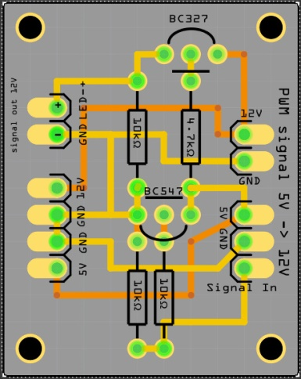 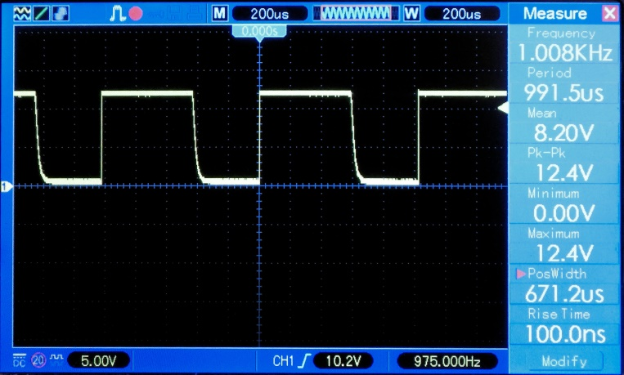

The output signal is almost a perfect block.

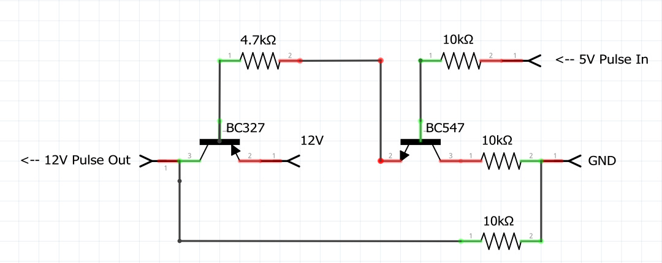

## Lower a 5V signal to a 3.3 V signal

## Lower 7V – 15V to 5 V

When the PCB in this project is used 5V and 12V is needed; 5V for the electronics and 12V for the LEDs.

Very handy is a 12V/5V power supply. Search for: AC-DC Dual Output 220V to 12V 5V Isolated Switch Power Module Buck.

But if one does not want to have 220V in the project or want to use an external power supply one need to lower the voltage

Four types of voltage regulator are shown. The Step down converters are the most efficient.

The L7805CV often needs to be cooled with a heat sink. This is a piece of metal to which the power regulator is attached.

The 78L05 is for small currents up to 0.1 A. (TO-92 and TO-220 is the name of the casing, how the regulator looks)

|  |  |  |  |
| --- | --- | --- | --- |
|  | | | |
| http://datasheetcafe.databank.netdna-cdn.com/wp-content/uploads/2016/02/WS78L05-datasheet.gif | http://4.bp.blogspot.com/-9yVN9TjZ5Lg/UnOSuJ-4lPI/AAAAAAAAALE/nvkAUZYQg1A/s1600/ic-7805.png |  |  |
| 78L05 TO-92  100 mA of output current. | L7805CV TO-220  1.5A of output current | DC-DC 9V/12V/24V to 5V 1.5A Step Down Power Module | Mini-360 DC-DC 4.75V-23V to 1V-17V Buck Converter Step Down |

## Use the DCF77 time receiver

It is always trouble to get a time signal in your program. Nowadays time modules are very cheap and exact and deviate no more than 10 seconds every year. But that annoying summer and winter time changing two times a year in troublesome.

You can pick time from a time server from internet but then you need WIFI or cable connection to your router. You can use a GPS to retrieve the time from but then you have to located your receiver to a location it ca see the sky. You can use FM-radio and extract the RDS time signal. But radio stations are not exact with their time and may deviate minutes from the real time. Also FM-radio stations do not have a fixed frequency for every station.  
You can use an old telephone and a cheap SIM.

But we can also fall back to an ancient signal stored in a radio wave.

Since 1905 time signals are transmitted by radio. This signal can be received with low cost receivers made of a ferrite rod. In Europe the DCF77 signal sent from a transmitter situated in Mainflingen, Germany at a frequency of 77.5 kHz.

|  |  |
| --- | --- |
|  |  |
| Time pulse signal | DCF77 receiver module |

The time signal is just like a Morse-signal, but a slow one. In every second there is a short or long pulse. The short pulse is 0.1 s and the long lasts 0.2 s. After 59 seconds one has a sequence of 59 bits. The last second is silent. This is the alignment signal.

A lot of information is stored in these 59 bits.

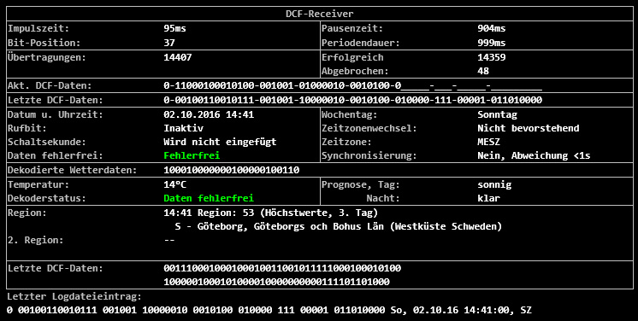

This signal can be fed into the ATMEGA processor. But there is also a drawback. Microwaves, processor chips and other radio wave interfere with this perfect pulse. The ferrite rod has to be placed horizontal and preferable pointing perpendicular to the transmitter.

Several libraries are already written to translate the signal to a time stamp. The Arduino IDE contains the library from Thijs Elenbaas and this library can be installed from the library manager.  
I [wrote a non interrupt routine](https://github.com/ednieuw/DCF77_NoInterrupt) to decode the signal. Combining both methods can boost the proper received times by more than 50%.  
Have a look at the [DCF77-transceiver](../DCF77_transceiver/DCFtransceiverklok.html) clock

For our project a LED is used to check if a proper signal is received. The LED should blink regularly every second. If you look closed you can see the difference between a long and a short pulse. If the led flashed erratically then you should turn the rod or move it away from your PC.

WS2812 RGB LEDs have a small processor in every LED and this processor interferes with the reception.

I bought my DCF77-module from [ELV elektronik AG](http://www.elv.de/dcf-empfangsmodul-dcf-2.html). The DCF-2 module operates between 1.2 V – 15 V and gives a pulse between 0 and 5 V and therefore easy to connect in the Arduino environment.

Some DCF-modules give a 5 V signal on the pulse while others have an inverted signal.

There are two ways to deal with it.

Invert the signal with a NPN transistor like the BC327.

|  |  |
| --- | --- |
|  |  |
| DCF77 time signal | Pulse inverter |

Or use the not documented library function to invert the signal.

The library initialization contains a third parameter. OnRisingFlank. This is default set to true (HIGH).

Initialize the library as follows: DCF77 DCF = DCF77(DCF_PIN,DCF_INTERRUPT, LOW);

Below are some not documented functions the library gives you to use:

DCF77(DCF77Pin, DCFinterrupt, OnRisingFlank); // Initialize library

time_t getTime(); // Returns the current time in CET

time_t getUTCTime(); // Returns the current time in UTC

Start(); // Start listening to DCF77 signal

Stop(); // Stop listening to DCF77 signal

After updating the libraries and boards some compiling errors occurred:

After changing #include "Time.h” in #include "TimeLib.h" the source code compiled again without errors.

Informational links with info about DCF receivers:  
[Online signal from Mainflingen on website](http://www.dcf77logs.de/WebConsole.aspx)  
Explains the bits in the received string [Arduino projects 4you](http://arduino-projects4u.com/home-weather-station/)  
HKW-Elektronik GmbH  [Sells all kinds of receivers](http://www.hkw-shop.de/Empfangstechnik-AM/)  
[Rheinturmfunkuhr mit Arduino](http://www.hjberndt.de/soft/rtctftdcf.html)   
[Arduino DCF77 radio clock receiver, Matthias Dalheimer](https://gonium.net/md/2006/11/05/arduino-dcf77-radio-clock-receiver/index.html)   
[Github Thijs Elenbaas](https://github.com/thijse/)  
[Conrad receiver](http://www.conrad.com/ce/en/product/641138/DCF-receiver-board)  
<http://www.elv.de/dcf-empfangsmodul-dcf-2.html>

The program below can be used with an ATMEGA 1284P or the Arduino UNO 328P processor. Four libraries are needed and all are included in the Arduino IDE.

Connect the DCF-77 and the RTC-clock. The clock can be the Tiny RTC-module or the DS3231 RTC- module than can be bought cheap on EBay. But probably every I2C clock module will work.

The LED should be flashing regularly, every second once. Keep de DCF77 antenna far away from your PC. An oscilloscope is very handy to check the DCF77 signal.

// =============================================================================================================================

/*

Title ..: DCF with 1284P - 328P

Author .: Ed Nieuwenhuys Oct 2016

*/

// ===============================================================================================================================

//--------------------------------------------

// ARDUINO Definition of installed modules

//--------------------------------------------

#include <Wire.h>

#include "DCF77.h"

#include "TimeLib.h"

#include <RTClib.h>

//--------------------------------------------

// PIN Assigments

//--------------------------------------------

#if defined(__AVR_ATmega328P__)

// Digital hardware constants ATMEGA 328 ----

enum DigitalPinAssignments {

DCF_PIN = 2, // DCFPulse on interrupt pin

DCF_LED_Pin = 9, // define pin voor AM PM Led

secondsPin = 13};

// Analogue hardware constants ----

enum AnaloguePinAssignments {

SDA_pin = 4, // SDA pin

SCL_pin = 5}; // SCL pin

# endif

//--------------------------------------------//--------------------------------------------

#if defined(__AVR_ATmega1284P__) || defined(__AVR_ATmega1284__)

// Digital hardware constants ATMEGA 1284P ----

enum DigitalPinAssignments {

DCF_PIN = 2, // DCFPulse on interrupt pin

DCF_LED_Pin = 10, // define pin voor AM PM Led

secondsPin = 29};

// Analogue hardware constants ----

enum AnaloguePinAssignments {

SDA_pin = 17, // SDA pin

SCL_pin = 16}; // SCL pin

# endif

//--------------------------------------------

// CLOCK

//--------------------------------------------

static unsigned long msTick; // the number of millisecond ticks since we last incremented the second counter

byte Isecond, Iminute, Ihour, Iday, Imonth, Iyear;

byte SecPulse = 0; // give a pulse to the Isecond led

String SerialString;

//--------------------------------------------

// DS3231 CLOCK MODULE

//--------------------------------------------

RTC_DS3231 RTC; //RTC_DS1307 RTC;

DateTime Inow;

//--------------------------------------------

// DCF-2 DCF77 MODULE

//--------------------------------------------

byte DCF_signal = 0; // is a proper time received?

#if defined(__AVR_ATmega328P__)

#define DCF_INTERRUPT 0 // DCF Interrupt number associated with DCF_PIN

#endif

#if defined(__AVR_ATmega1284P__) || defined(__AVR_ATmega1284__)

#define DCF_INTERRUPT 2 // DCF Interrupt number associated with DCF_PIN

#endif

time_t tijd;

DCF77 DCF = DCF77(DCF_PIN,DCF_INTERRUPT,LOW);

// End Definitions ---------------------------------------------------------

//--------------------------------------------

// ARDUINO Loop

//--------------------------------------------

void loop(void)

{

SerialCheck();

DCF77Check();

EverySecondCheck();

}

//--------------------------------------------

// ARDUINO Setup

//--------------------------------------------

void setup()

{ // initialise the hardware // initialize the appropriate pins as outputs:

pinMode(DCF_LED_Pin, OUTPUT);

pinMode(secondsPin, OUTPUT );

pinMode(DCF_PIN, INPUT_PULLUP);

Serial.begin(9600); // setup the serial port to 9600 baud

DCF.Start(); // start the DCF-module

Wire.begin(); // start the wire communication I2C

RTC.begin(); // start the RTC-module

DateTime now = RTC.now(); // Get the time from the RTC

DateTime compiled = DateTime(__DATE__, __TIME__);

if (now.unixtime() < compiled.unixtime())

{

Serial.println("RTC is older than compile time! Updating"); // following line sets the RTC to the date & time this sketch was compiled

RTC.adjust(DateTime(F(__DATE__), F(__TIME__)));

}

GetTijd(0); // Get the time and print it to serial

}

// --------------------------- END SETUP

//--------------------------------------------

// CLOCK Update routine done every second

//--------------------------------------------

void EverySecondCheck(void)

{

if ( millis() - msTick >50) digitalWrite(secondsPin,LOW); // Turn OFF the second on pin 13

if ( millis() - msTick >999) // Flash the onboard Pin 13 Led so we know something is happening

{

msTick = millis(); // second++;

digitalWrite(secondsPin,HIGH); // turn ON the second on pin 13

++SecPulse; // second routine in function DimLeds

GetTijd(0); // synchronize time with RTC clock

// Print_tijd();

}

}

//--------------------------------------------

// CLOCK check for DCF input

//--------------------------------------------

void DCF77Check(void)

{

time_t DCFtime = DCF.getTime(); // Check if new DCF77 time is available

if (DCFtime!=0)

{

Serial.print(F("Time is updated -----> "));

DCF_signal++;

setTime(DCFtime);

RTC.adjust(DCFtime);

digitalClockDisplay();

}

digitalWrite(DCF_LED_Pin,1-digitalRead(DCF_PIN)); // write inverted DCF pulse to LED on board

}

//--------------------------------------------

// CLOCK check for serial input

//--------------------------------------------

void SerialCheck(void)

{

while (Serial.available())

{

delay(3);

char c = Serial.read();

if (c>31 && c<128) SerialString += c; // allow input from Space - Del

}

if (SerialString.length()>0) ReworkInputString(SerialString); // Rework ReworkInputString();

SerialString = "";

}

//--------------------------------------------

// DS3231 Get time from DS3231

//--------------------------------------------

void GetTijd(byte printit)

{

Inow = RTC.now();

Ihour = Inow.hour();

Iminute = Inow.minute();

Isecond = Inow.second();

// if (Ihour > 24) { Ihour = random(12)+1; Iminute = random(60)+1; Isecond = 30;} // set a time if time module is absent or defect

if (printit) Print_RTC_tijd();

}

//--------------------------------------------

// DS3231 utility function prints time to serial

//--------------------------------------------

void Print_RTC_tijd(void)

{

if (Inow.hour() < 10) Serial.print(F("0"));

Serial.print(Inow.hour(), DEC);

Serial.print(F(":"));

if (Inow.minute() < 10) Serial.print(F("0"));

Serial.print(Inow.minute(), DEC);

Serial.print(F(":"));

if (Inow.second() < 10) Serial.print(F("0"));

Serial.print(Inow.second(), DEC);

Serial.print(F(" "));

Serial.print(Inow.day(), DEC);

Serial.print(F("/"));

Serial.print(Inow.month(), DEC);

Serial.print(F("/"));

Serial.println(Inow.year(), DEC);

}

//--------------------------------------------

// CLOCK utility function prints time to serial

//--------------------------------------------

void Print_tijd(void)

{

if (Ihour < 10) Serial.print(F("0"));

Serial.print(Ihour);

Serial.print(F(":"));

if (Iminute < 10) Serial.print(F("0"));

Serial.print(Iminute);

Serial.print(F(":"));

if (Isecond < 10) Serial.print(F("0"));

Serial.println(Isecond);

}

//--------------------------------------------

// DCF77 utility function prints DCF time

//--------------------------------------------

void digitalClockDisplay()

{

// // digital clock display of the time

Serial.print(hour());

printDigits(minute());

printDigits(second());

Serial.print(F(" "));

Serial.print(day());

Serial.print(F(" "));

Serial.print(month());

Serial.print(F(" "));

Serial.print(year());

Serial.println();

}

//--------------------------------------------

// DCF77 utility function prints preceding colon and leading 0

//--------------------------------------------

void printDigits(int digits)

{

Serial.print(F(":"));

if(digits < 10)

Serial.print(F("0"));

Serial.print(digits);

}

//--------------------------------------------

// DS3231 Set time in module and print it

//--------------------------------------------

void SetRTCTime(void)

{

RTC.adjust(DateTime(Inow.year(), Inow.month(), Inow.day(), Ihour, Iminute, Isecond));

GetTijd(0); // synchronize time with RTC clock

Print_tijd();

}

//--------------------------------------------

// CLOCK Input from Serial

//--------------------------------------------

void ReworkInputString(String InputString)

{

String temp;

float ff;

Serial.println(InputString);

if (InputString.length() > 3 && InputString.length() <7 )

{

temp = InputString.substring(0,2);

Ihour = temp.toInt();

if (InputString.length() > 3) { temp = InputString.substring(2,4); Iminute = temp.toInt(); }

if (InputString.length() > 5) { temp = InputString.substring(4,6); Isecond = temp.toInt(); }

SetRTCTime();

}

InputString = "";

temp = "";

}

//*****************

## Using a FM-radio to receive time from the RDS signal and tune to a station

In a FM-radio transmission a RDS-signal is send. The signal contains information the radio station want to broadcast. Many stations broadcast the time every minute. Not all do and some stations send times that are off several minutes.

In this project we want to extract the time from this RDS signal.

There are several FM tuner chips. The Silicon labs SI4703 andSI4705, the Philips/NXP TEA5700 family and the RDA RDA5807M radio tuners are easy to use in the Arduino platform because we can use the [Arduino library from Matthias Hertel](http://www.mathertel.de/Arduino/RadioLibrary.aspx).

But as often, the RDS time could not be retrieved with this standard Arduino library.

The [on website from R Hoerman](http://arduino.vom-kuhberg.de/index.php) I found coding I could use the read the time from the RDS-signal.

He made plain coding and with the RDS5807M Datasheet it was possible to write a RDS-time read function

The chip connects with an I2C protocol to the SDA and SCL lines A4 and A5 on the Arduino UNO

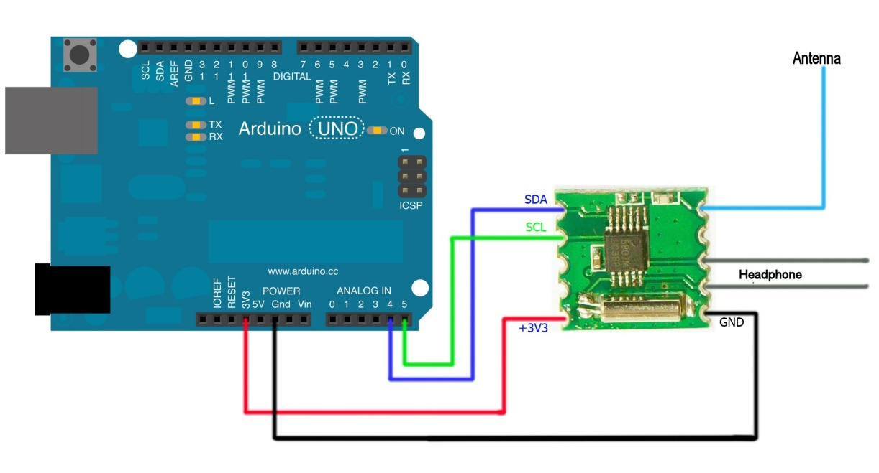

An extract of the code from [Character_Clock_V095_328-1284_ZW-BT-FM-DCF.ino](Source_INO_files/Character_Clock_V095_328-1284_ZW-BT-FM-DCF/Character_Clock_V095_328-1284_ZW-BT-FM-DCF.ino) is below

The source still needs a routine to find the best station with a proper time RDS-signal.

This routine must continuously check if the best station is received.

Maybe two ‘best’ stations should be chosen. If they get out of sync the routine must start a new scan to find the best stations again

For now the best station can be set via Bluetooth or in the program it self.

// FM radio -----------------------

byte RadioUur; // reading from RDS FM-radio

byte RadioMinuut; // reading from RDS FM-radio

float fini = 103.50; //91.60; // 103.50; //98.10; // Start frequency

int ftun; // Selected frequency

float Freq_lower_bandwith = 87.00;// lower Band limit

float Freq_tuned; //

int RDA5807_adrs = 0x10; // I2C-Address RDA Chip for sequential Access

int RDA5807_adrr = 0x11; // I2C-Address RDA Chip for random Access

int RDA5807_adrt = 0x60; // I2C-Address RDA Chip for TEA5767like Access

int sidx = 0; // Counter of frequency array

int vol = 0; // Volume

int rssi = 0; // Signal-Level

unsigned int auRDS[32];

unsigned int auRDA5807_Reg[32];

unsigned int aui_RDA5807_Reg[32];

unsigned int aui_buf[8];

unsigned int auRDA5807_Regdef[10] ={

0x0758, // 00 defaultid

0x0000, // 01 not used

0xD009, // 02 DHIZ,DMUTE,BASS, POWERUPENABLE,RDS

0x0000, // 03

0x1400, // 04 DE ? SOFTMUTE

0x84D0, // 05 INT_MODE, SEEKTH=0110,????, Volume=0

0x4000, // 06 OPENMODE=01

0x0000, // 07 unused ?

0x0000, // 08 unused ?

0x0000 // 09 unused ?

};

// END FM radio ------------------------

//--------------------------------------------

// Setup

//--------------------------------------------

void setup()

{

Setup_FMradio();

}

//--------------------------------------------

// Loop

//--------------------------------------------

void loop(void)

{

FMradioCheck();

}

//--------------------------------------------

// RDA5807 Setup_FMradio

//--------------------------------------------

void Setup_FMradio(void)

{

RDA5807_PowerOn();

RDA5807_Reset();

RDA5807_setFreq(fini);

}

//--------------------------------------------

// RDA5807 Reset Chip to Default Configuration

//--------------------------------------------

int RDA5807_Reset()

{

Serial.println(F("RESET RDA5807"));

for(int i = 0;i < 7; i++) {auRDA5807_Reg[i] = auRDA5807_Regdef[i];}

auRDA5807_Reg[2] = auRDA5807_Reg[2] | 0x0002; // Enable SoftReset

int ret = RDA5807_Write();

auRDA5807_Reg[2] = auRDA5807_Reg[2] & 0xFFFB; // Disable SoftReset

return ret;

}

//----------------------------------------

// RDA5807 Power Off

//----------------------------------------

int RDA5807_PowerOff()

{

RDA5807_setVol(0);

Serial.println("Power OFF RDA5807");

aui_RDA5807_Reg[2]=0x0001; // all bits off

return RDA5807_Write();

auRDA5807_Reg[2] =auRDA5807_Regdef[2]; // Reset to Default Value

}

//----------------------------------------

// RDA5807 Power On

//----------------------------------------

int RDA5807_PowerOn()

{

Serial.println(F("Power ON RDA5807"));

auRDA5807_Reg[3] = auRDA5807_Reg[3] | 0x010; // Enable Tuning

auRDA5807_Reg[2] = auRDA5807_Reg[2] | 0x001; // Enable PowerOn

int ret = RDA5807_Write();

auRDA5807_Reg[3] = auRDA5807_Reg[3] & 0xFFEF; // Disable Tuning

return ret;

}

//----------------------------------------

// RDA5807 Seek up to next Station

//----------------------------------------

int RDA5807_SeekUp()

{

Serial.println(F("SeekUp"));

auRDA5807_Reg[2] = auRDA5807_Reg[2] | 0x0300; // Enable Seekup

RDA5807_Write();

auRDA5807_Reg[2] = auRDA5807_Reg[2] & 0xFCFF; // Disable Seekup

return 0;

}

//----------------------------------------

// RDA5807 Seek down to next Station

//----------------------------------------

int RDA5807_SeekDown()

{

Serial.println(F("SeekDown"));

auRDA5807_Reg[2] = auRDA5807_Reg[2] | 0x0100; // Enable SeekDown(default)

RDA5807_Write();

auRDA5807_Reg[2] = auRDA5807_Reg[2] & 0xFCFF; // Disable Seek

return 0;

}

//----------------------------------------

// RDA5807 Tune Radio to defined Frequency

//----------------------------------------

int RDA5807_setFreq(float mhz)

{

ftun = mhz * 100.0;

Freq_tuned = mhz;

int Chnumber = (int)(( 0.01 + mhz - Freq_lower_bandwith ) / 0.1);

Serial.print(F("Frequency: "));

Serial.print(ftun);

Serial.print(F(" Channel: "));

Serial.println(Chnumber);

Chnumber = Chnumber & 0x03FF;

auRDA5807_Reg[3] = Chnumber * 64 + 0x10; // Channel + TUNE-Bit + Band=00(87-108) + Space=00(100kHz)

Wire.beginTransmission(RDA5807_adrs);

Wire_write16(0xD009);

Wire_write16(auRDA5807_Reg[3]);

Wire.endTransmission();

return 0;

}

//----------------------------------------

// RDA5807 Set Volume

//----------------------------------------

int RDA5807_setVol(int setvol)

{

vol = setvol;

if (vol > 15) {vol = 15; Serial.println(F("Vol already maximal")); return 1; }

if (vol < 0) {vol = 0; Serial.println(F("Vol already minimal")); return 1; }

Serial.print(F("Volume=")); Serial.println(vol);

auRDA5807_Reg[5] = (auRDA5807_Reg[5] & 0xFFF0)| vol; // Set New Volume

RDA5807_WriteReg(5);

return 0;

}

//----------------------------------------

// Write 16Bit To I2C / Two Wire Interface

//----------------------------------------

void Wire_write16(unsigned int val)

{

// if (b_debug) { Serial_print16h(val);}

Wire.write(val >> 8); Wire.write(val & 0xFF);

}

//------------------------------------------

// Serial Print 16Bit Number in HEX as hh:ll

//------------------------------------------

void Serial_print16h(unsigned int uval)

{

byte b_high,b_low;

b_high = uval >> 8; b_low = uval & 0xFF;

if (b_high < 0x10){ Serial.write('0');} Serial.print(b_high,HEX); Serial.write(':');

if (b_low < 0x10){ Serial.write('0');} Serial.print(b_low ,HEX);

}

//----------------------------------------

// RDA5807 Set all Configuration Registers

//----------------------------------------

int RDA5807_Write()

{

Wire.beginTransmission(RDA5807_adrs);

for ( int i = 2; i < 7; i++) { Wire_write16(auRDA5807_Reg[i]);}

return Wire.endTransmission();

}

//----------------------------------------

// RDA5807 Set one Configuration Registers

//----------------------------------------

int RDA5807_WriteReg(int reg)

{

Wire.beginTransmission(RDA5807_adrr);

Wire.write(reg);

Wire_write16(auRDA5807_Reg[reg]);

return Wire.endTransmission();

}

//---------------------------------------------

// RDA5807 Read Special Data Registers as Word

//---------------------------------------------

void RDA5807_ReadW(int cnt)

{

Wire.beginTransmission(RDA5807_adrr); // Device 0x11 for random access

Wire.write(0x0C); // Start at Register 0x0C

Wire.endTransmission(0); // restart condition

Wire.requestFrom(RDA5807_adrr,2*cnt, 1); // Retransmit device address with READ, followed by 8 bytes

for (int i = 0; i < cnt; i++) // Loop for Read data

{auRDS[i] = 256 * Wire.read() + Wire.read();} // Read Data into Array of Unsigned Ints

Wire.endTransmission();

}

//----------------------------------------

// RDA5807 Read and Show all Status Registers

//----------------------------------------

int RDA5807_ReadStatus()

{

int Chnumber = -1;

unsigned int aubuf[8];

memset (aubuf, 0, 8);

Serial.println(F("Info Status RDA5807:"));

Serial.println(F("Reg | 0Ah | 0Bh | 0Ch | 0Dh | 0Eh | 0Fh |"));

Serial.print(F(" |"));

Wire.requestFrom(RDA5807_adrs, 12);

for (int i = 0; i < 6; i++) { aubuf[i] = 256 * Wire.read () + Wire.read(); }

Wire.endTransmission();

for (int i = 0; i < 6; i++) { Serial_print16h(aubuf[i]); Serial.print("|"); }

Serial.println();

Chnumber = (aubuf[0] & 0x03FF);

Freq_tuned = Freq_lower_bandwith + Chnumber * 0.10;

rssi = aubuf[1] >> 10;

Serial.print(F("RDS Data: ")); if ((aubuf[0] & 0x8000)==0){ Serial.println(F("NO"));} else {Serial.println(F("NEW data"));}

Serial.print(F("SEEK Ready: ")); if ((aubuf[0] & 0x4000)==0){ Serial.println(F("no"));} else {Serial.println(F("OK"));}

Serial.print(F("SEEK Fail: ")); if ((aubuf[0] & 0x2000)==0){ Serial.println(F("no, Succces!"));} else {Serial.println(F("FAILED"));}

Serial.print(F("RDS Sync: ")); if ((aubuf[0] & 0x1000)==0){ Serial.println(F("no"));} else {Serial.println(F("OK"));}

Serial.print(F("RDS Block: ")); if ((aubuf[0] & 0x0800)==0){ Serial.println(F("no"));} else {Serial.println(F("Block E"));}

Serial.print(F("Stationmode: ")); if ((aubuf[0] & 0x0400)==0){ Serial.println(F("Mono "));} else {Serial.println(F("Stereo"));}

Serial.print(F("Channel Nr: ")); Serial.print(Chnumber); Serial.print(F(" = "));

Serial.print(Freq_tuned); Serial.println(F(" MHz"));

Serial.print(F("SignalLevel: ")); Serial.println(rssi);

return 0;

}

//----------------------------------------

// RDA5807 Report all available Stations

//----------------------------------------

int RDA5807_Report()

{

Freq_tuned = Freq_lower_bandwith;

int cnt_stations = 0;

int cnt_stereo = 0;

int cnt_rds = 0;

int Rssi = 0;

//auRDA5807_Reg[3] = 0x10; //Set channelnumber 0

//RDA5807_setFreq(87.50);

Serial.println(F("Sender Report:"));

for(int Chnumber = 0; Chnumber <= 210; Chnumber++)

{

auRDA5807_Reg[3] = 64 * Chnumber + 0x10;

Wire.beginTransmission(RDA5807_adrs);

Wire_write16(0xD009);

Wire_write16(auRDA5807_Reg[3]);

Wire.endTransmission();

delay(300); //give de radio some time to settle

RDA5807_Status();

}

}

//----------------------------------------

// RDA5807 Show Status

//----------------------------------------

void RDA5807_Status(void)

{

int Chnumber;

Wire.requestFrom (RDA5807_adrs, 16);

for (int i = 0; i < 8; i++) { auRDA5807_Reg[0x0A + i] = 256 * Wire.read () + Wire.read(); }

Wire.endTransmission();

Chnumber = auRDA5807_Reg[0x0A] & 0x03FF;

rssi = auRDA5807_Reg[0x0B] >> 10;

Freq_tuned = Freq_lower_bandwith + (Chnumber ) * 0.1;

// if ( (auRDA5807_Reg[0x0A] & 0x8000) && (auRDA5807_Reg[0x0A] & 0x0400) ) // if RDS and stereo in station

if ((auRDA5807_Reg[0x0A] & 0x0400) ) // if Stereo in station

{

if (Freq_tuned <= 99.99){Serial.print(" ");}

Serial.print(Freq_tuned);

Serial.print(F(" MHz"));

Serial.print(F(" Ch=")); if (Chnumber < 10){Serial.print(F(" "));} if (Chnumber < 100) { Serial.print(F(" ")); } Serial.print(Chnumber);

Serial.print(F(" PI=")); Serial_printuih(auRDA5807_Reg[0x0C]); // RDS Block A contains Station ID

if ((auRDA5807_Reg[0x0A] & 0x0400) == 0) { Serial.print(F(" Mono "));} else { Serial.print(F(" Stereo"));}

if ((auRDA5807_Reg[0x0A] & 0x8000) == 0) { Serial.print(F(" ---")); } else { Serial.print(F(" RDS")); }

Serial.print(F(" Sig= ")); if (rssi < 10) { Serial.print(F(" ")); } else Serial.print(rssi); Serial.print(F(" "));

for(int i = 0; i < rssi - 5; i++) { Serial.print(F("*")); }

Serial.println();

}

}

//----------------------------------------

// RDA5807 Show Status

//----------------------------------------

void RDA5807_Get_RSSI()

{

Wire.requestFrom (RDA5807_adrs, 16);

for (int i = 0; i < 8; i++) { auRDA5807_Reg[0x0A + i] = 256 * Wire.read () + Wire.read(); }

Wire.endTransmission();

rssi = auRDA5807_Reg[0x0B] >> 10;

}

//----------------------------------------

// SerialPrint 16Bit Number in HEX as hhll

//----------------------------------------

void Serial_printuih(unsigned int val)

{

if (val < 0xF) Serial.print(F("0")); // if less 2 Digit

if (val < 0xFF) Serial.print(F("0")); // if less 3 Digit

if (val < 0xFFF) Serial.print(F("0")); // if less 4 Digit

Serial.print(val,HEX);

Serial.print(F(" "));

}

//----------------------------------------

// RDA5807 Radio Data System Dump Infos

//----------------------------------------

int RDA5807_RDS_Dump()

{

Serial.println(" PI |GTxx|Asci");

while(Serial.available()==0)

{

RDA5807_ReadW(4); // Read RDS-Data as 4 Word to Array

if((auRDS[1] & 0xF000)==0x2000)

{

// Serial_printuih(auRDS[0]); // Block A PI

// Serial_printuih(auRDS[1]); // Block B GT(5Bit)T(1Bit) PTY(5Bit)POS(5)Bit

// Serial_printuih(auRDS[2]);

// Serial_printuih(auRDS[3]);

// int x = 16 + 4*(auRDS[1] & 0x000F);

for (int i=2;i<4;i++)

{

Serial.write(auRDS[i]>>8); // Block C/D Ascii Code

Serial.write(auRDS[i]&0xFF); // 2 * 2 Byte

}

}

if ((auRDS[1] & 0xF000)==0x4000)

{

int i_hh =(16*(auRDS[2] & 0x0001)+((auRDS[3] & 0xF000)>>12));

int i_mm =(auRDS[3] & 0x0FC0)>>6;

int i_ofs=(auRDS[3] & 0x003F);

i_hh=i_hh+(i_ofs/2);

if (i_hh <10){Serial.write(' ');} Serial.print(i_hh); Serial.write(':');

if (i_mm <10){Serial.write('0');} Serial.print(i_mm); Serial.write(' ');

}

if ((auRDS[1]& 0xF000)==0x400)

{

Serial.print(F("RDS CT: ")); for (int i=0;i<4;i++){ Serial_print16h(auRDS[i]); Serial.write(' | ');} Serial.println();

}

delay(80);

Serial.println();

}

return 0;

}

//----------------------------------------

// RDA5807 Radio Data System Dump Infos

//----------------------------------------

int RDA5807_RDS_DumpCT()

{

int i_gt,i_gab,i_pty,i_t,i_pos,i_hh,i_mm,i_ofs;

RDA5807_Status();

Serial.println(F(" PI |GTxx|Asci GT T PTY POS HH:mm Offset"));

while(Serial.available()==0)

{

RDA5807_ReadW(4); // Read RDS-Data as 4 Word to Array

i_gt = auRDS[1] >>12;

if ((auRDS[1] & 0x0800)==0){i_gab='A';} else {i_gab='B';}

i_t =(auRDS[1] & 0x0400)>10;

i_pty=(auRDS[1] & 0x03FF)>>5;

i_pos=(auRDS[1] & 0x000F);

i_hh =(16*(auRDS[2] & 0x0001)+((auRDS[3] & 0xF000)>>12));

i_mm =(auRDS[3] & 0x0FC0)>>6;

i_ofs=(auRDS[3] & 0x003F);

i_hh=i_hh+(i_ofs/2);

if (i_gt==4)

{

Serial_printuih(auRDS[0]); // Block A PI

Serial_printuih(auRDS[1]); // Block B GT(4Bit) A/B(1Bit) T(1Bit) PTY(5Bit)POS(5)Bit

Serial_printuih(auRDS[2]);

Serial_printuih(auRDS[3]);

if (i_gt <10){Serial.write(' ');} Serial.print(i_gt); Serial.write(i_gab); Serial.write(' ');

if (i_t <10){Serial.write(' ');} Serial.print(i_t); Serial.write(' ');

if (i_pty<10){Serial.write(' ');} Serial.print(i_pty); Serial.print(" ");

if (i_pos<10){Serial.write(' ');} Serial.print(i_pos); Serial.write(" ");

if (i_hh <10){Serial.write(' ');} Serial.print(i_hh); Serial.write(':');

if (i_mm <10){Serial.write('0');} Serial.print(i_mm); Serial.write(' ');

Serial.print(i_ofs);

Serial.println();

}

delay(80);

}

return 0;

}

## Using a GPS to receive time and position on the globe

A GPS gives a very exact time. There are two drawbacks. A GPS must see the sky for a proper signal and winter and summer time should be programmed.

A good tutorial can be found here:

<http://playground.arduino.cc/Tutorials/GPS>

## Use the Bluetooth HC-05 and HM-10 4.0 BT-BLE modules to send and receive messages

Communication with Bluetooth modules takes place through the serial pin RX and TX on the ATMEGA chip

The library Softwareserial.h makes it possible to use other pins than the standard pins 0 and 1 that are also used to upload programs.

The HC-05 module is very cheap but cannot connect to Apple devices.

The identical looking HM-10 module can but then you can get problems connecting to Microsoft and Android devices.

Below is a method to change the name in a HC-05 Bluetooth-module:

First we need to connect the HC-05 module to an Arduino.

Connect VCC to 3.3V on the Arduino and GND to GND, connect pin 6 to TXD and pin 7 to RXD on the Bluetooth-module.

So RX goes to TX and TX is connected to RX; “the wires are crossed”

The module has a default name like HC-05. First we will change that name.

Load the following sketch into the Arduino:

-------------------------

#include< SoftwareSerial.h>

SoftwareSerial BTSerial(6, 7); // RX | TX

void setup()

{

pinMode(9, OUTPUT); // this pin will pull the HC-05 pin 34 (key pin) HIGH to switch module to AT mode

digitalWrite(9, HIGH);

Serial.begin(9600);

Serial.println("Enter AT commands:");

BTSerial.begin(38400); // HC-05 default speed in AT command more

}

void loop()

{

// Keep reading from HC-05 and send to Arduino Serial Monitor

if (BTSerial.available())

Serial.write(BTSerial.read());

// Keep reading from Arduino Serial Monitor and send to HC-05

if (Serial.available())

BTSerial.write(Serial.read());

}

---------------------------------

Detach the USB-cable to make the module powerless.

Connect a thin wire between 3.3V of the Arduino and pin 34. (Top right of the Bluetooth-module when the connection pins are pointing down)

Connect the Arduino to the PC, start the Arduino IDE programmer and open “Serial monitor”.

The red LED of the Bluetooth-module start blinking 2sec on, 2 sec off.

Enter in the Serial monitor:

AT 🡪 OK

AT+NAMEDevice01 (Or any other name you like to give the module)

AT+RESET

The passkey of the module = 1234 when you connect

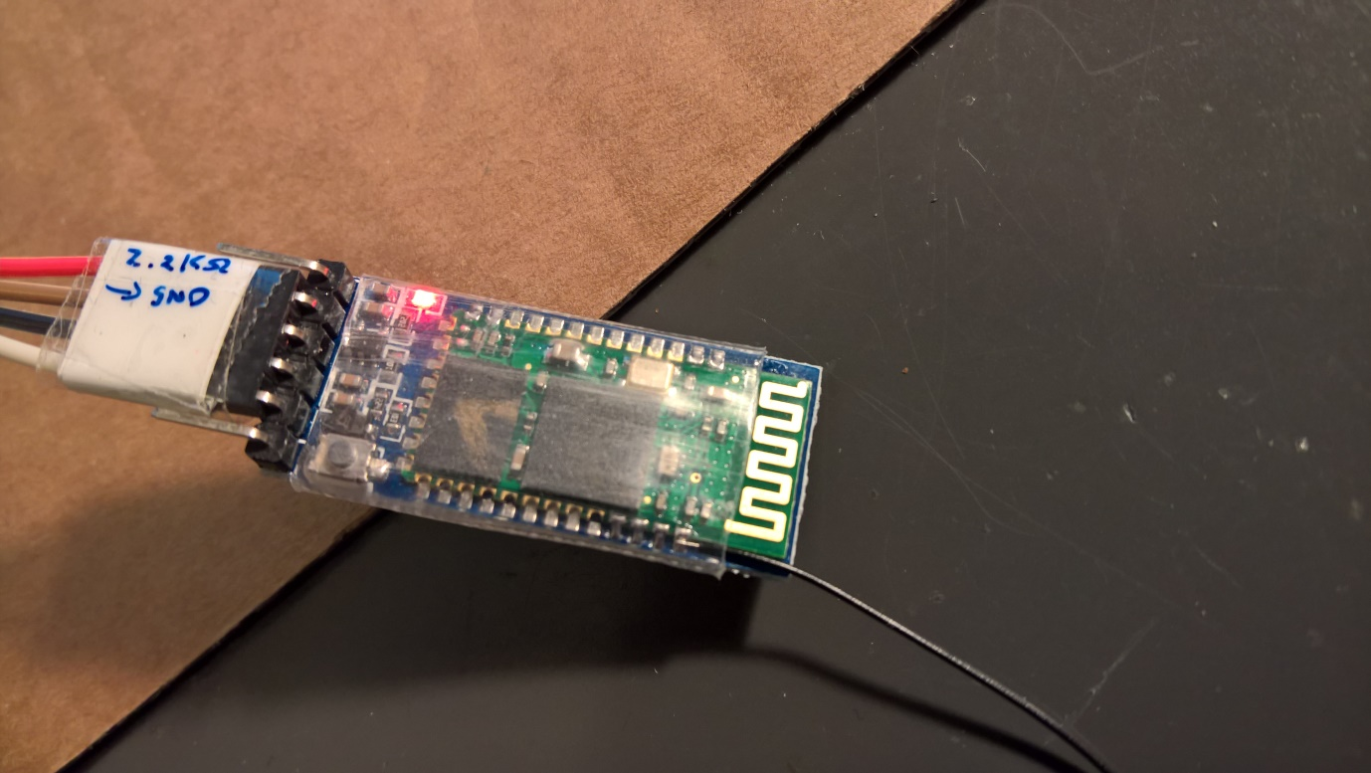

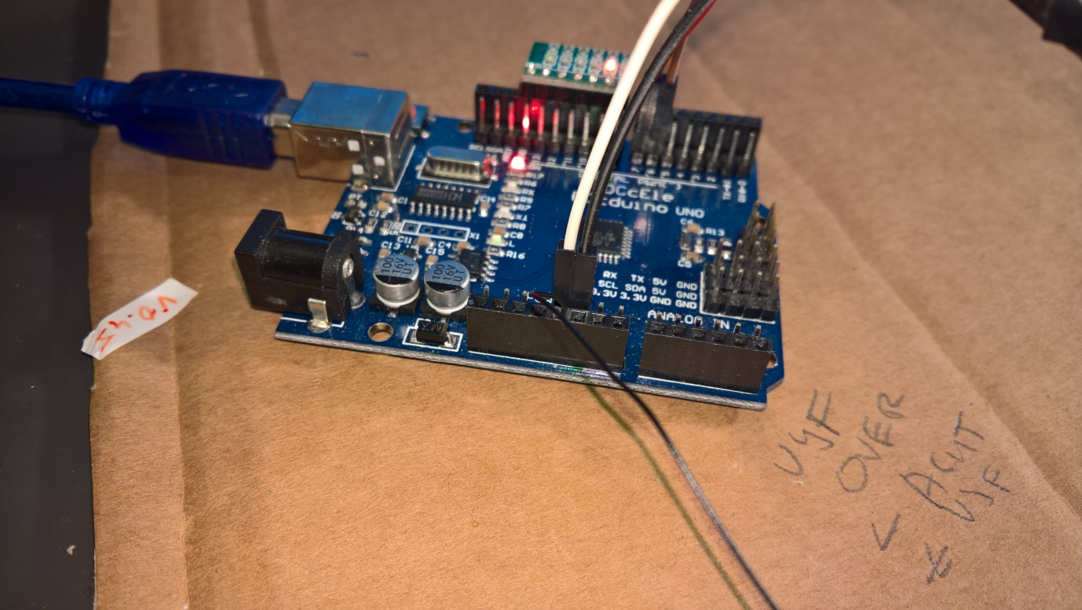

Here is a method to change the name in a HM-10 4.0 BT-BLE Bluetooth-module:

First we need to connect the HM10-module to an Arduino.

Connect VCC to 3.3V on the Arduino and GND to GND, connect pin 6 to TXD and pin 7 to RXD on the Bluetooth-module.

So RX goes to TX and TX is connected to RX; “the wires are crossed”

The module has a default name like CC41-A. First we will change that name.

Load the following sketch into the Arduino Uno:

-------------------------

#include <SoftwareSerial.h>

SoftwareSerial mySerial(6, 7); // RX, TX

// Connect HM10 Arduino Uno

// Pin TXD Pin 6

// Pin RXD Pin 7

void setup() {

Serial.begin(9600);

// If the baudrate of the HM-10 module has been updated,

// you may need to change 9600 by another value

// Once you have found the correct baudrate,

// you can update it using AT+BAUDx command

// e.g. AT+BAUD0 for 9600 bauds

mySerial.begin(9600);

}

void loop() {

char c;

if (Serial.available()) {

c = Serial.read();

mySerial.print(c);

}

if (mySerial.available()) {

c = mySerial.read();

Serial.print(c);

}

}

Start the serial monitor in the Arduino IDE.

Change right under in the monitor the LF&CR settings to “No line ending” and the baud rate to 9600 Baud

Enter in the Serial monitor:

AT+RESET

AT+NAMEDevice01 (Or any other name you like to give the module)

AT+RESET

The passkey of the module = 0000 when you pair the devices

Fake HM10 modules, bottom one, lack a crystal.

The fake ones cannot be programmed as described above.

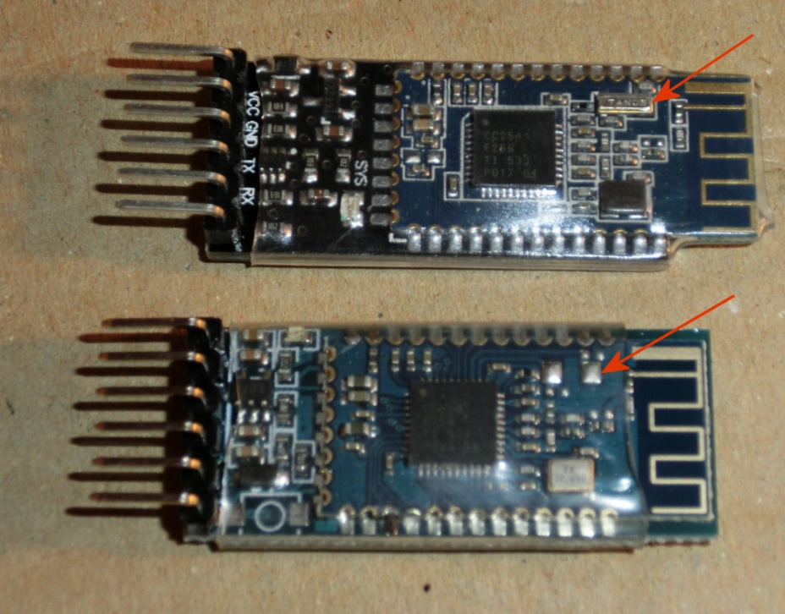

Part of example code

//--------------------------------------------

// BLUETOOTH

//--------------------------------------------

// Bluetooth ---------------------

SoftwareSerial Bluetooth(6, 7); // RX, TX

String BluetoothString;

//--------------------------------------------

// Check for Bluetooth input

//--------------------------------------------

void BluetoothCheck(void)

{

while (Bluetooth.available())

{

delay(3);

char c = Bluetooth.read();

if (c>31 && c<128) BluetoothString += c;

}

if (BluetoothString.length()>0) ReworkInputString(BluetoothString);

BluetoothString = "";

}

//--------------------------------------------

// Input from Bluetooth or Serial

//--------------------------------------------

void ReworkInputString(String InputString)

{

String temp;

float ff;

Serial.println(InputString);

if ( InputString[0] > 64 )

{

int val = InputString[0];

switch (val)

{

case 'A':

case 'a':

Serial.println(F("A was the first character"));

break;

case 'B':

case 'b':

Serial.println(F("B was the first character"));

break;

case 'C':

case 'c':

Serial.println(F("C was the first character"));

break;

case 'F':

case 'f':

//set FM frequency

temp = InputString.substring(1);

FMfreq = temp.toInt();

if (FMfreq < 8750 ) FMfreq = 8750;

if (FMfreq > 10800) FMfreq = 10800;

RDA5807_setFreq((float) FMfreq/100);

break;

default:

break;

}

InputString = "";

}

}

## Change the name of a HM10 BLE with an FTDI

The easiest method to change or program a HM-10 module is using a FTDI programmer.   
Connect the 3.3V and GND and TX to RX and RX to TX.  
Open an serial monitor like [Termite](https://www.compuphase.com/software_termite.htm) or de Arduino Serial monitor and open the serial port  
Enter AT in the monitor and OK should show up in the window as response of the module  
AT+NAME followed with the desired name give the module a new broadcasting name.

AT+HELP list the following commands:

********************************************************************

* Command Description *

* ---------------------------------------------------------------- *

* AT Check if the command terminal work normally *

* AT+RESET Software reboot *

* AT+VERSION Get firmware, bluetooth, HCI and LMP version *

* AT+HELP List all the commands *

* AT+NAME Get/Set local device name *

* AT+PIN Get/Set pin code for pairing *

* AT+PASS Get/Set pin code for pairing *

* AT+BAUD Get/Set baud rate *

* AT+LADDR Get local bluetooth address *

* AT+ADDR Get local bluetooth address *

* AT+DEFAULT Restore factory default *

* AT+RENEW Restore factory default *

* AT+STATE Get current state *

* AT+PWRM Get/Set power on mode(low power) *

* AT+POWE Get/Set RF transmit power *

* AT+SLEEP Sleep mode *

* AT+ROLE Get/Set current role. *

* AT+PARI Get/Set UART parity bit. *

* AT+STOP Get/Set UART stop bit. *

* AT+START System start working. *

* AT+IMME System wait for command when power on. *

* AT+IBEA Switch iBeacon mode. *

* AT+IBE0 Set iBeacon UUID 0. *

* AT+IBE1 Set iBeacon UUID 1. *

* AT+IBE2 Set iBeacon UUID 2. *

* AT+IBE3 Set iBeacon UUID 3. *

* AT+MARJ Set iBeacon MARJ . *

* AT+MINO Set iBeacon MINO . *

* AT+MEA Set iBeacon MEA . *

* AT+NOTI Notify connection event . *

* AT+UUID Get/Set system SERVER_UUID . *

* AT+CHAR Get/Set system CHAR_UUID . *

* -----------------------------------------------------------------*

* Note: (M) = The command support slave mode only. *

* For more information, please visit http://www.cyobd.com *

* Copyright@2013 www.cyobd.com. All rights reserved. *

********************************************************************

## Communicate with Android, Windows and Apple devices

With a HM10 BLE module the clock can communicate with Apple IOS and Android.  
For Apple IOS the program BLE Terminal HM-10 from the app store can be used.  
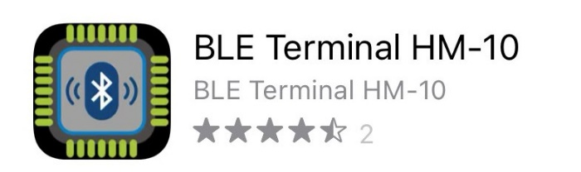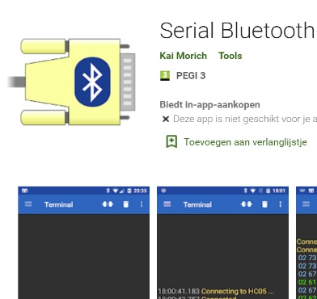

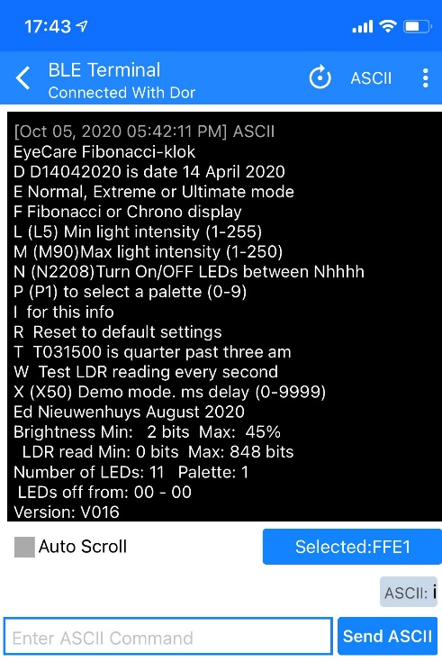  
Serial Bluetooth Terminal van Kai Morich works fine as terminal.  
For Windows 10 I can not find a workable program.

Connect in the app with your HM-10 module.  
Then you can type a command in the send of enter message box or wait if your program logs results in the console window

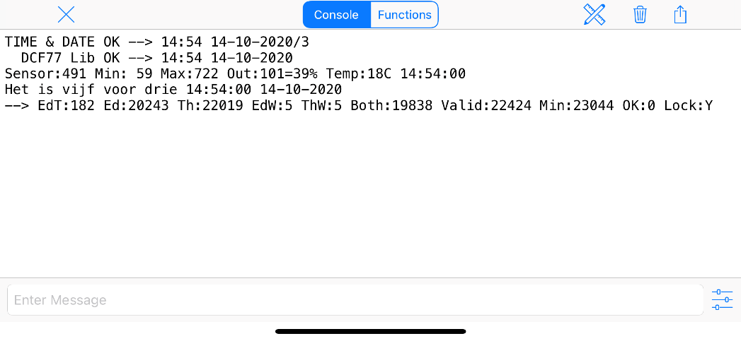

## Communicate with a LCD display

LCD displays with 2x16 or 4x20 characters are very cheap and easy to use for displaying information generated by the program when the serial monitor is not available anymore.

We can buy them with an I2C communication module attached to it. Without this module the display can also be used but uses six connections and misses the advances I2C that allows us to chain more devices on the two I2C lines.

I2C uses unique addresses for the communication with the I2C devices. 0X27, 0X3F, 0X38

On the I2C module it is possible to change the device address by closing the solder pads A0, A1 or A2. Default they are all open.

Above the pads there is the contrast control.

When you buy the displays you often do not know the device address. With the I2C scanner program below it is possible to retrieve this address.

|  |  |  |  |  |  |  |  |  |  |  |  |  |  |  |  |  |  |  |  |  |  |  |  |  |  |  |  |  |  |  |  |  |  |  |  |  |  |
| --- | --- | --- | --- | --- | --- | --- | --- | --- | --- | --- | --- | --- | --- | --- | --- | --- | --- | --- | --- | --- | --- | --- | --- | --- | --- | --- | --- | --- | --- | --- | --- | --- | --- | --- | --- | --- | --- |
| |  |  |  |  | | --- | --- | --- | --- | | A0 | A1 | A2 | HEX Address | | O | O | O | 0x27 | | C | O | O | 0x26 | | O | C | O | 0x25 | | C | C | O | 0x24 | | O | O | C | 0x23 | | C | O | C | 0x22 | | O | C | C | 0x21 | | C | C | C | 0x20 |   O = open, C = closed |  |
|  | |

// **I2C Scanner**

// Written by Nick Gammon

// Date: 20th April 2011

#include <Wire.h>

void setup() {

**Serial**.begin (115200);

// Leonardo: wait for serial port to connect

while (!**Serial**)

{

}

**Serial**.println ();

**Serial**.println ("I2C scanner. Scanning ...");

byte count = 0;

Wire.begin();

for (byte i = 8; i < 120; i++)

{

Wire.beginTransmission (i);

if (Wire.endTransmission () == 0)

{

**Serial**.print ("Found address: ");

**Serial**.print (i, DEC);

**Serial**.print (" (0x");

**Serial**.print (i, HEX);

**Serial**.println (")");

count++;

delay (1); // maybe unneeded?

} // end of good response

} // end of for loop

**Serial**.println ("Done.");

**Serial**.print ("Found ");

**Serial**.print (count, DEC);

**Serial**.println (" device(s).");

} // end of setup

void loop() {}

## Display on a 8 Digit LED Display MAX7219 7 Segment Digital Tube

With this cheap and easy to program breakout board it is easy to display numeric data. The board uses an MAX7219 chip.

With the used internal Arduino IDE library one can chain up to eight daisy chained MAX72XX drivers.

Install the library “LedControl” available in the Arduino IDE library manager



//We always have to include the library

#include "LedControl.h"

/*

Now we need a LedControl to work with.

***** These pin numbers will probably not work with your hardware *****

pin 12 is connected to the DataIn (DIN)

pin 11 is connected to the CLK

pin 10 is connected to LOAD (CS)

We have only a single MAX72XX.

*/

LedControl lc = LedControl(12,11,10,1);

/* we always wait a bit between updates of the display */

unsigned long delaytime = 500;

void setup() {

/*

The MAX72XX is in power-saving mode on startup,

we have to do a wakeup call

*/

lc.shutdown(0,false); // Set the brightness to a medium values

lc.setIntensity(0,2); // and clear the display

lc.clearDisplay(0);

}

void loop()

{

char text[8];

int n = sprintf(text,"%8ld", millis() );

setDisplayToString(text);

}

// The setChar(addr,digit,value,dp)-function accepts a value of type char for the

// in the range of a 7-bit ASCII encoding. Since the recognizable patterns are limited,

// most of the defined characters will print the <SPACE>-char.

// But there are quite a few characters that make sense on a 7-segment display.

// Display a character on a 7-Segment display.

// Params:

// addr = address of the display (0 - 7)

// digit = the position of the character on the display (0..7)

// value = the character to be displayed.

// dp = sets the decimal point.

void setDisplayToString(char text[])

{

for(byte n=0;n<8;n++) lc.setChar(0,7-n, text[n] ,(n==4?1:0)); //decimal point at 4th char

}

## Add a temperature sensor Dallas DS1820

At [Tweaking4all](https://www.tweaking4all.com/hardware/arduino/arduino-ds18b20-temperature-sensor/) a detailed description can be read.

With the Dallas DS1820 temperature sensors it is easy to measure temperature.

Up to 16 (or more?) sensors can be chained. If many sensors are chained the 4.7 kOhm resistor must be replaced with a lower resistance resistor.

Several types of sensor can be bought.

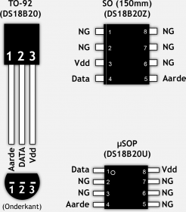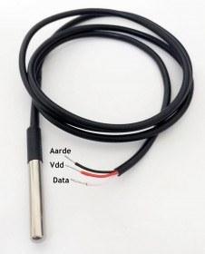

In this example the temperature of the Dallas DS1820 sensor is displayed on an 8 Digit LED Display MAX7219 7 Segment Digital Tube.

Install the Onewire, LedControl and MAX31850 library in the library manager of the Arduino IDE.

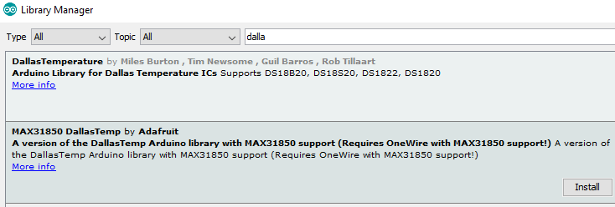  
Connect the display and temperature reader as shown.

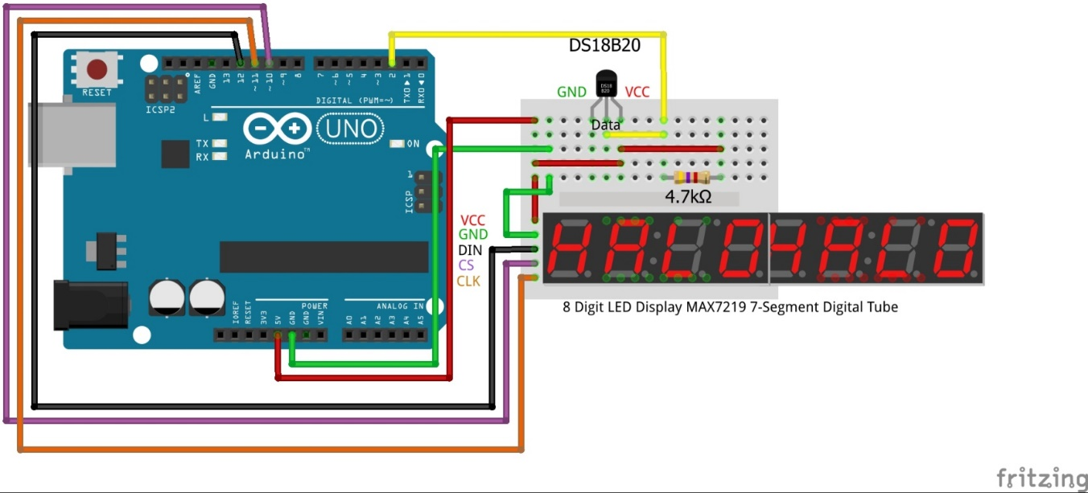

Or chained them up.

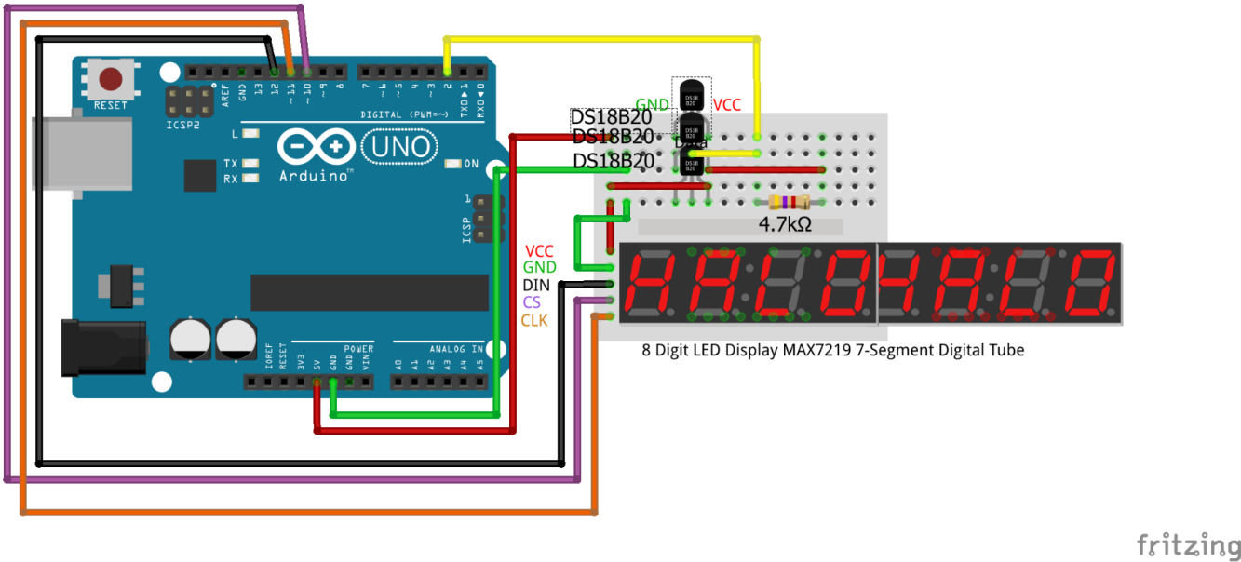

Load the source code.

#include <LedControl.h>

#include <OneWire.h>

#include <DallasTemperature.h>

LedControl lc = LedControl(12,11,10,1); // pin 10 is connected to LOAD, pin 11 to CLK, pin 12 to DataIn

#define ONE_WIRE_BUS 2 // Data wire is plugged into port 2 on the Arduino

#define TEMPERATURE_PRECISION 12 // a DS18B20 takes from 94ms (9-bit resolution) to 750ms (12-bit resolution) to convert temperature

OneWire oneWire(ONE_WIRE_BUS); // Setup a oneWire instance to communicate with any OneWire devices

DallasTemperature Tempsensors(&oneWire); // Pass our oneWire reference to Dallas Temperature.

int numberOfDevices; // Number of temperature devices found

DeviceAddress tempDeviceAddress; // We'll use this variable to store a found device address

//-------------------------------------------------------------------------------------------

void setup() {

lc.shutdown(0,false); // The MAX72XX is in power-saving mode on startup, we have to do a wakeup call

lc.setIntensity(0,2); // Set the brightness to a medium values

lc.clearDisplay(0); // and clear the display

Serial.begin(9600); // start serial port

Tempsensors.begin(); // Start up the library

numberOfDevices = Tempsensors.getDeviceCount(); // Grab a count of devices on the wire

Serial.print("Found "); Serial.print(numberOfDevices, DEC); Serial.println(" devices.");

Serial.print("Parasite power is: "); // report parasite power requirements

if (Tempsensors.isParasitePowerMode()) Serial.println("ON");

else Serial.println("OFF");

for(int i=0;i<numberOfDevices; i++) // Loop through each device, print out address

{

if(Tempsensors.getAddress(tempDeviceAddress, i)) // Search the wire for address

{

Serial.print("Found device "); Serial.print(i, DEC); Serial.print(" with address: "); printAddress(tempDeviceAddress); Serial.println();

Serial.print("Setting resolution to "); Serial.println(TEMPERATURE_PRECISION, DEC);

Tempsensors.setResolution(tempDeviceAddress, TEMPERATURE_PRECISION);

delay(100);

Serial.print("Resolution actually set to: "); Serial.print(Tempsensors.getResolution(tempDeviceAddress), DEC); Serial.println();

}

else

{

Serial.print("Found ghost device at "); Serial.print(i, DEC);

Serial.println(" but could not detect address. Check power and cabling");

}

}

}

//-----------------------------------------------------------------------------------

void loop()

{

char text[8];

Tempsensors.requestTemperatures(); // Send the command to get temperatures

for(int i=0;i<numberOfDevices; i++) // Loop through each device, print out temperature data

{

if(Tempsensors.getAddress(tempDeviceAddress, i)) // Search the wire for address

{

Serial.print("Temperature for device: "); Serial.print(i,DEC); // Output the device ID

Serial.print(" Temp C: "); Serial.println(Tempsensors.getTempC(tempDeviceAddress));

sprintf(text,"%8ld", (long) (10 * Tempsensors.getTempC(tempDeviceAddress)) );

setDisplayToString(text,1);

} //else ghost device! Check your power requirements and cabling

}

delay(2000);

}

//-------------------------------------------------------------------------------

// addr-address of the display (0 - 7),digit-position of the character on the display(0..7)

// value-the character to be displayed, dp - sets the decimal point.

void setDisplayToString(char text[],byte Posdot)

{

for(byte n = 0; n < 8; n++)

lc.setChar(0,7-n, text[n] ,(n==(7-Posdot)?1:0)); // No of Posdot decimal positions

}

// function to print a device address

void printAddress(DeviceAddress deviceAddress)

{

for (uint8_t i = 0; i < 8; i++)

{

if (deviceAddress[i] < 16) Serial.print("0");

Serial.print(deviceAddress[i], HEX);

}}

## The WS2812 colour LEDS

## Use buttons

## Use a rotary KY-040

## Adjust some 1284P features

## Some knowhow of the 1284P

Like pins. A/D and digital pin

PWM

Bit Shift registers

Controlling B/W LED’s

Controlling WS2812 LEDS

<script>

(function(i,s,o,g,r,a,m){i['GoogleAnalyticsObject']=r;i[r]=i[r]||function(){

(i[r].q=i[r].q||[]).push(arguments)},i[r].l=1*new Date();a=s.createElement(o),

m=s.getElementsByTagName(o)[0];a.async=1;a.src=g;m.parentNode.insertBefore(a,m)

})(window,document,'script','https://www.google-analytics.com/analytics.js','ga');

ga('create', 'UA-88364661-1', 'auto');

ga('send', 'pageview');

</script>