One Wire Key Pad

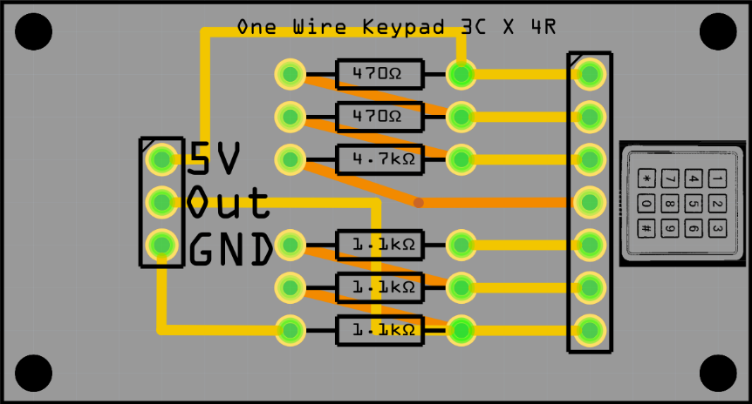
This tutorial describes how to wire a 3 colums * 4 rows key pad

